EXPERIMENT NO:12
AIM:Write a program to implement socket programming for chat application.
TOOLS/SOFTWARES REQUIRED: Cisco Packet tracer
THEORY:
Socket programming is a method used to enable communication between two systems over a network. A socket acts as an endpoint for sending and receiving data between devices.
In Python, the built-in socket module is used to implement socket programming. It provides functions to create, bind, listen, accept, connect, send, and receive data through sockets.
A chat application using sockets typically follows the client-server architecture:
- The server creates a socket, binds it to an IP address and port number, and listens for incoming connections.
- The client creates a socket and connects to the server using the same IP and port.
- Once the connection is established, both client and server can send and receive messages.
The communication process involves:
- Socket Creation – Both client and server create sockets.
- Binding (Server-side) – The server binds the socket to a specific address and port.
- Listening (Server-side) – The server listens for incoming client requests.
- Connection Establishment – The client connects to the server, and the server accepts the connection.
- Data Transmission – Messages are exchanged using send() and recv() functions.
- Termination – The connection is closed when either side sends an exit command.
Sockets can use different protocols, but this chat application uses the Transmission Control Protocol (TCP), which ensures reliable and ordered delivery of messages.

OUTPUT
Code: Server
import socket

server = socket.socket()
server.bind(("localhost", 12345))
server.listen(1)

print("Waiting for connection...")
conn, addr = server.accept()
print("Connected to:", addr)

while True:
msg = conn.recv(1024).decode()
print("Client:", msg)

if msg.lower() == "exit":
print("Client disconnected.")
break

reply = input("You: ")
conn.send(reply.encode())

if reply.lower() == "exit":
print("Closing connection.")
break

conn.close()
server.close()
Client:
import socket

client = socket.socket()
client.connect(("localhost", 12345))

while True:
msg = input("You: ")
client.send(msg.encode())

if msg.lower() == "exit":
print("Disconnected from server.")
break

reply = client.recv(1024).decode()
print("Server:", reply)

if reply.lower() == "exit":
print("Server closed the connection.")
break

client.close()

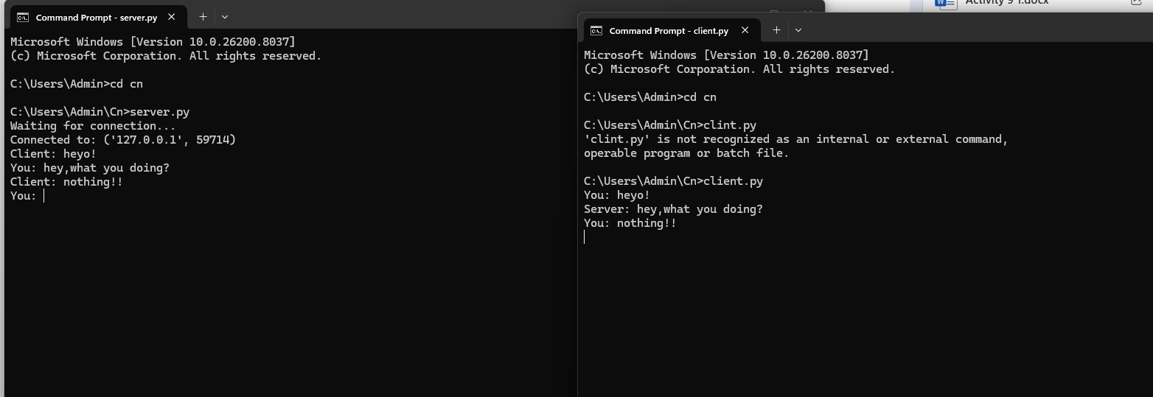
CONCLUSION:
In this experiment, a simple chat application was successfully implemented using socket programming in Python. The client and server were able to establish a connection and exchange messages in real time.
This program demonstrates the fundamental concepts of networking such as client-server communication, connection establishment, and data transmission. It also highlights the importance of proper synchronization and error handling in communication systems.
Overall, socket programming provides a powerful way to build real-time applications like chat systems, file transfer tools, and online games. This experiment helped in understanding how network communication works at a basic level and serves as a foundation for developing more advanced distributed applications.

